OOAD LAB EXPERIMENTS **DAY-4**

**27. Develop a system using UML for Supermarket Management System. The system should maintain the stock detail, employee detail, and customer details. The system should intimate the product with low stock and nearing the expiry date. The loyalty feature of the customers should be maintained. The offers to the customers should be based on their loyalty features.**

**AIM:-**

To develop a system using UML for Supermarket Management System.

UML DESIGNS:-

1.USE CASE:

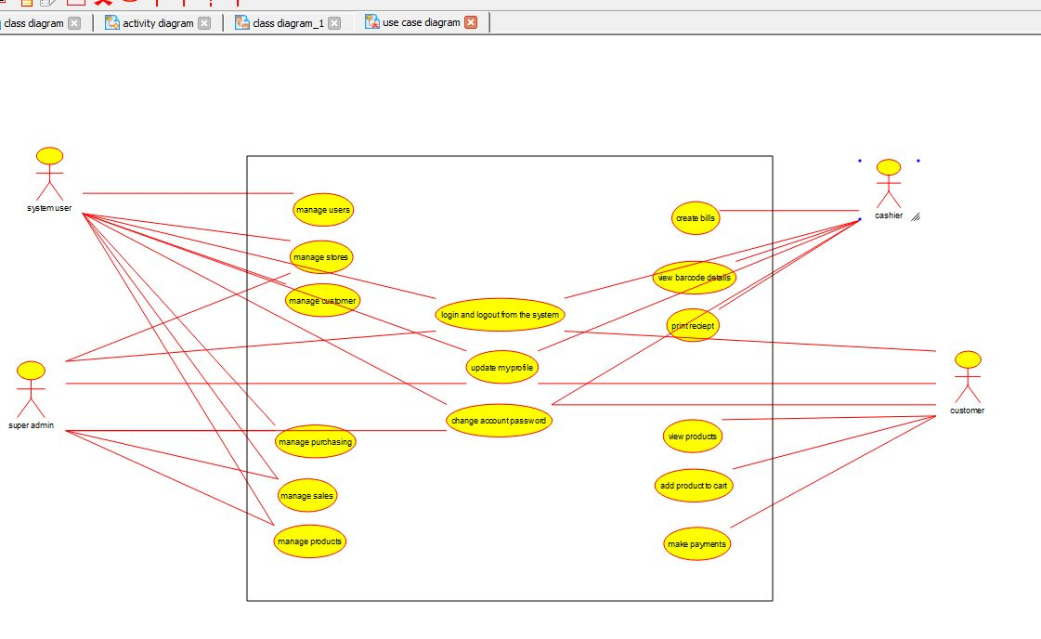

2.CLASS DIAGRAM:

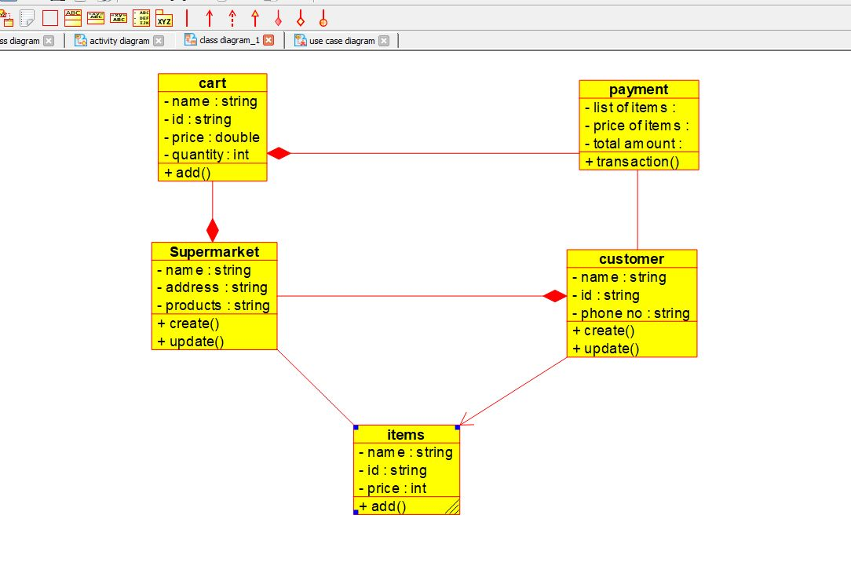

3.ACTIVITY DIAGRAM:

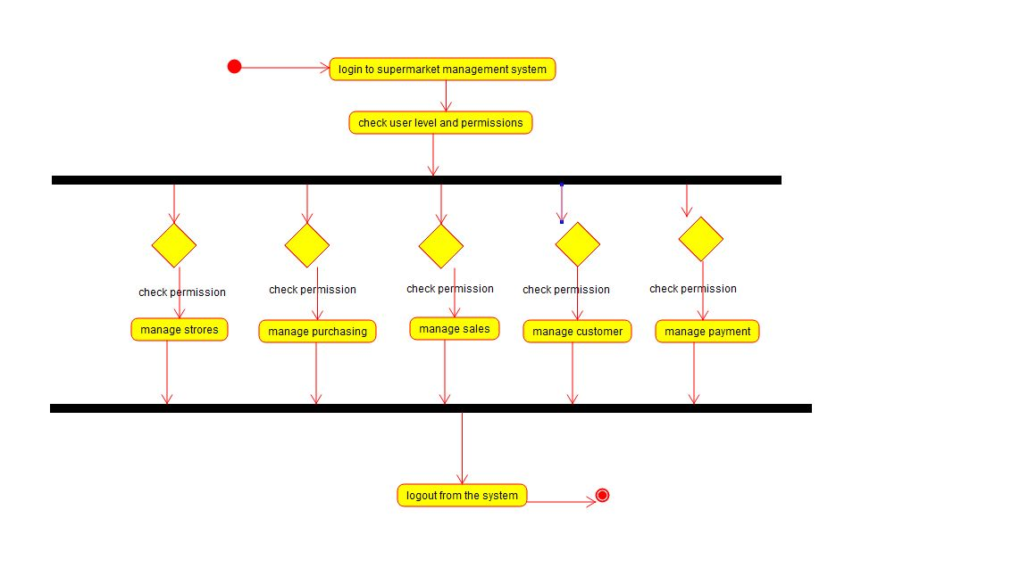

**28.** **Develop a system using UML for Airplane Reservation System. The customer can search for flights for a given data and source/destination airport and reserve the required seats, the system should handle the payment. The customer can view flight schedules and cancel their reservation(s) if needed. Admin can add new aircraft, flights, and flight schedules. Admin can cancel any prescheduled flight and a notification should be sent to all stakeholders.**

**AIM:-**

To develop a system using UML for Airplane Reservation System.

UML DESIGNS:-

1.ACTIVITY DIAGRAM:

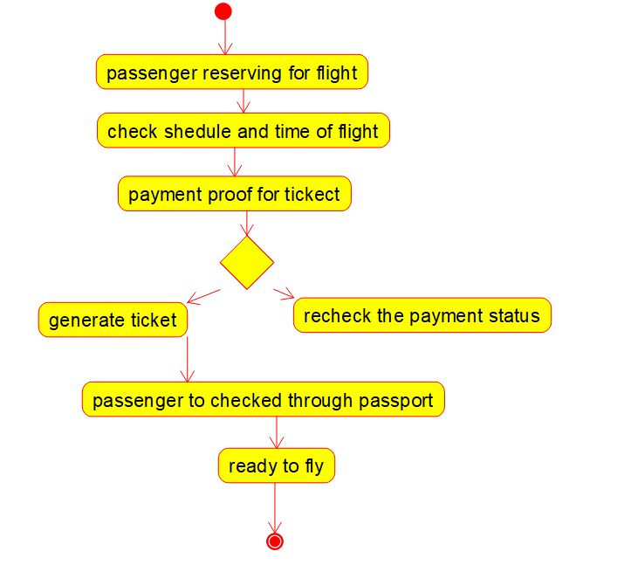

2.USECASE :

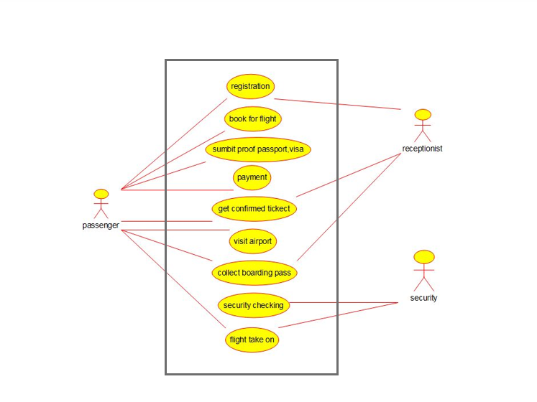

3.CLASS DIAGRAM:

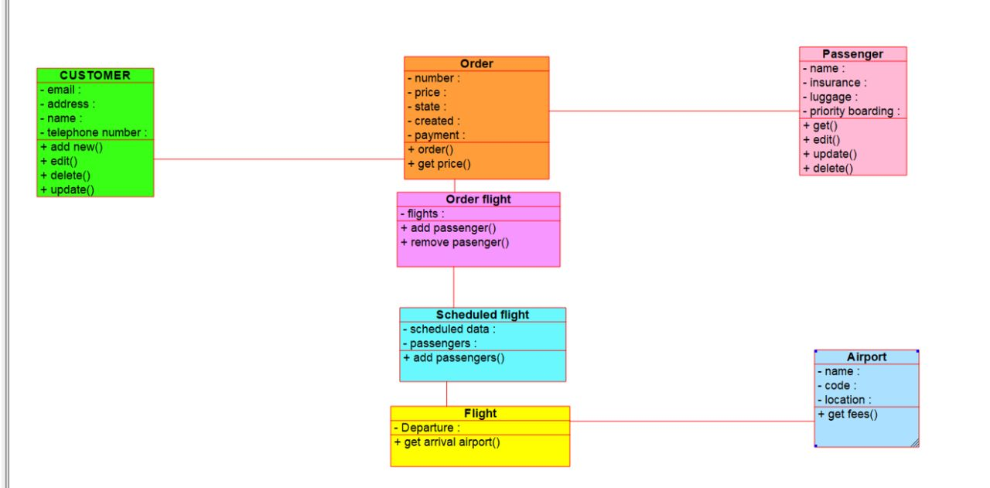

**29.** **Develop a system using UML for the Bus ticket Reservation System. The customer can create a login and the details are stored by the system. The customer can view the bus and seat availability from source to destination on a given date and time. The customer can book tickets and view the status of the bus. The customer can cancel the ticket and a refund will be decided based on the time remaining before the departure of the bus.**

**AIM:-**

To develop a system using UML for Bus ticket Reservation System.

UML DESIGNS:-

1.CLASS DIAGRAM:

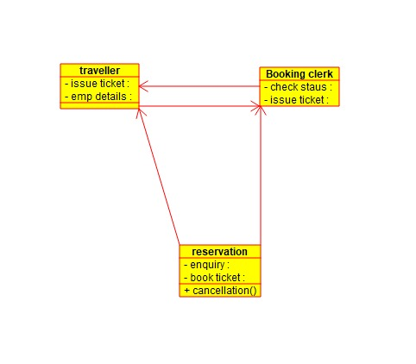

2.COMPONENT DIAGRAM:

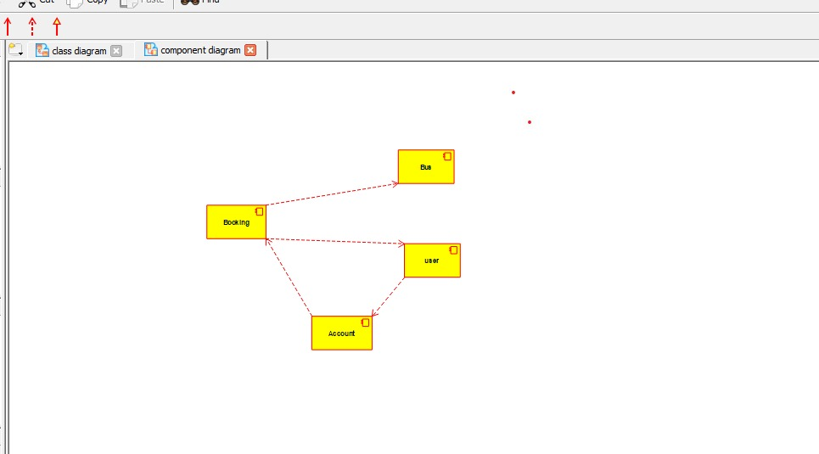

3.USE CASE DIAGRAM:

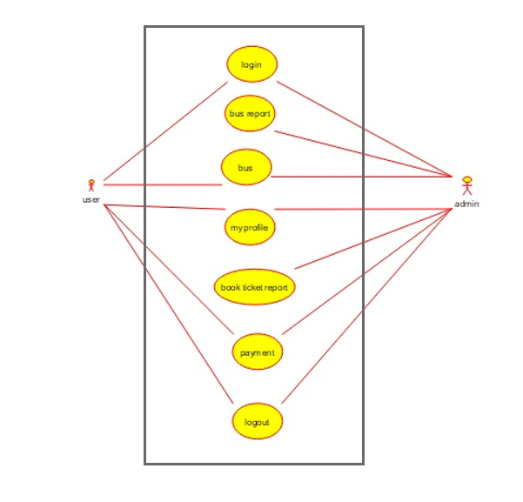

**30. Develop a system using UML for the Train ticket Reservation System. The customer can create a login and the details are stored by the system. The customer can view the train and seat availability from source to destination on a given date and time. The customer can book tickets and view the status of the train. The customer can cancel the ticket and a refund will be decided based on the time remaining before the departure of the bus.**

**AIM:-**

To develop a system using UML for the Train ticket Reservation System.

UML DESIGNS:-

1.USECASE:

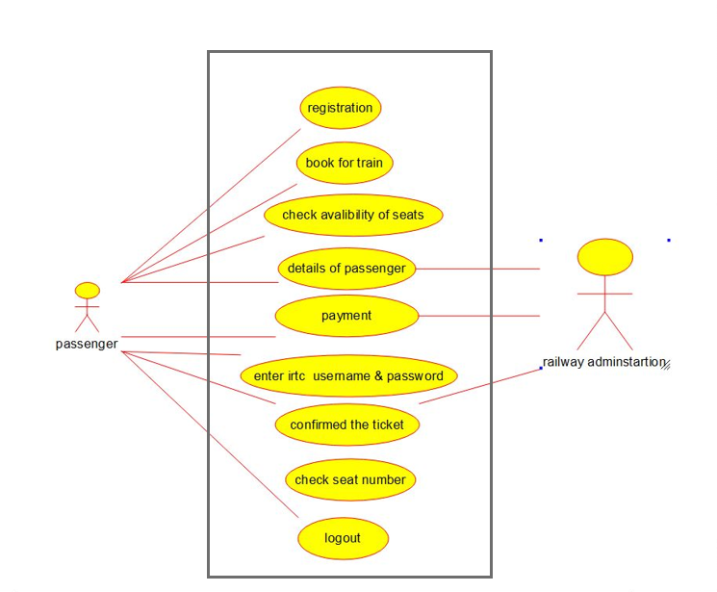

2. COMPONENT DIAGRAM:

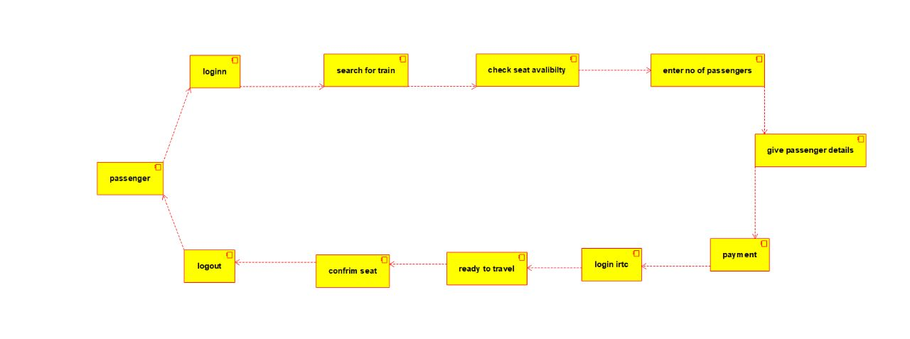

3.ACTIVITY DIAGRAM:

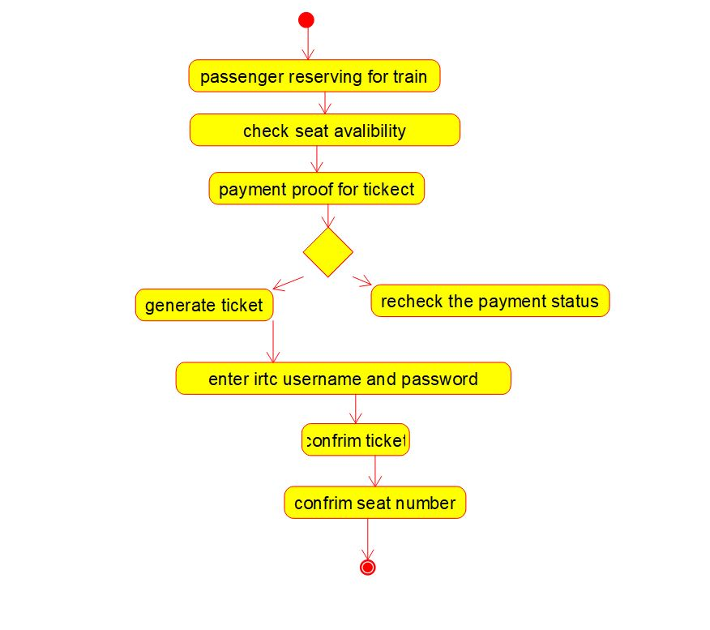

**31.** **Develop a system using UML for Agriculture Loan Management System. The admin should add new customers and view his/her records. The admin should check the defaulters. The customer can see his/her account detail and apply for a new loan by providing the required documents. The admin should verify the document submitted and approve the loan after verifying the payback potential of the customer.**

**AIM:-**

To develop a system using UML for Agriculture Loan Management System.

UML DESIGNS:-

1. USECASE DIAGRAM:

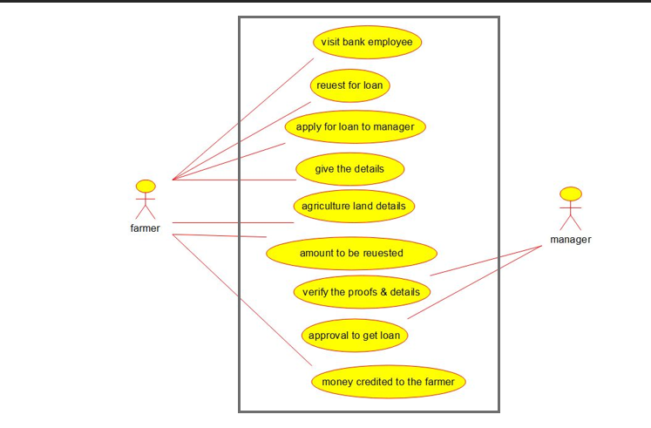

2.COMPONENT:

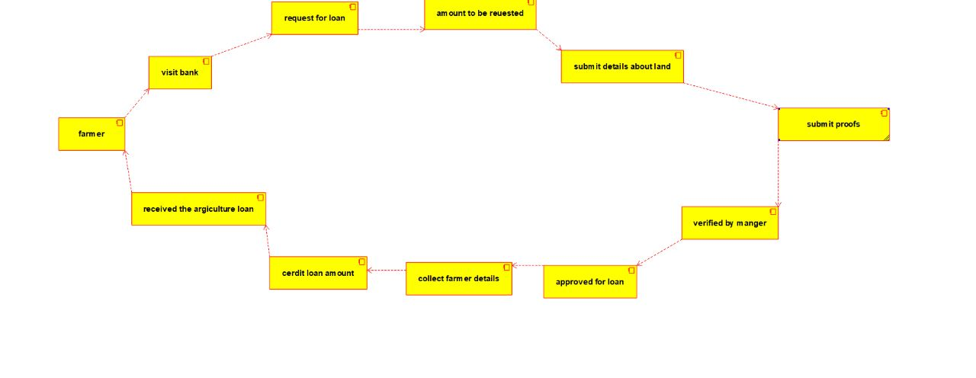

3.ACTIVITY DIAGRAM:

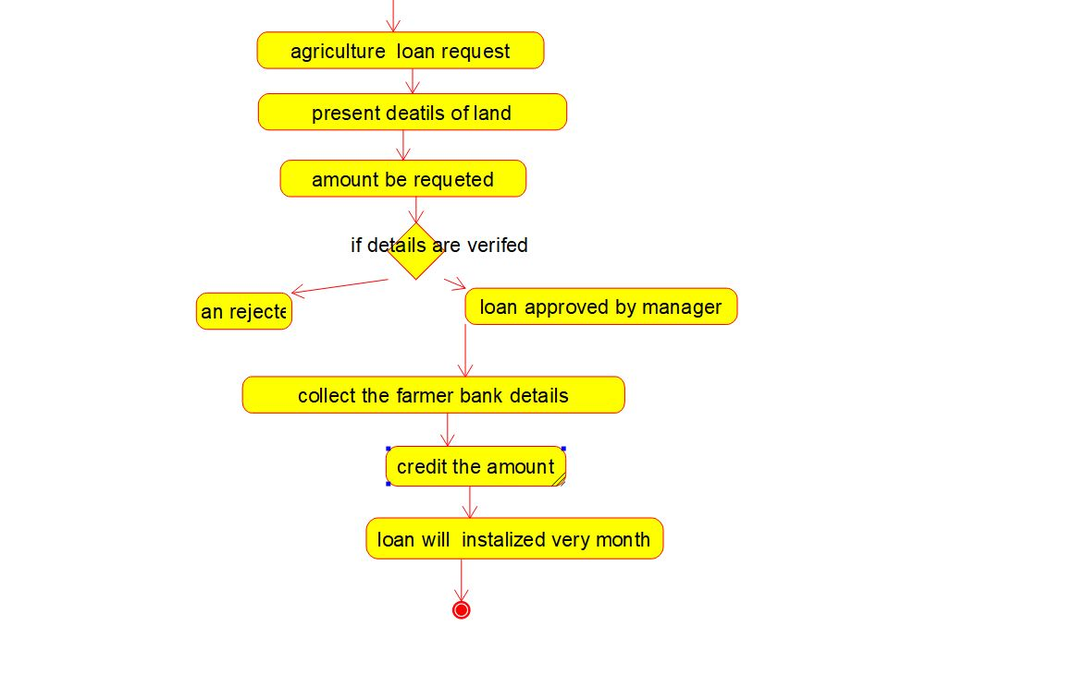

**32. Develop a system using UML for Jewel Loan Management System. The admin should add new customers and view the customers' records. The admin should check the defaulters. The customer can see his/her account detail and apply for a new loan by providing the required ornaments. The admin should verify the purity of the ornaments submitted and approve the loan after verifying the payback potential of the customer.**

**AIM:-**

To develop a system using UML for Jewel Loan Management System.

UML DESIGNS:-

1.STATECHART DIAGRAM:

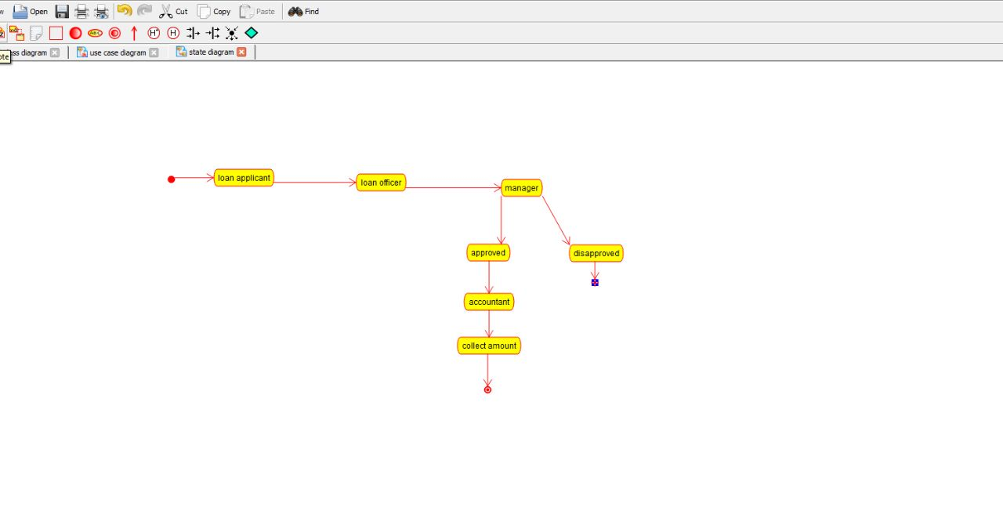

2.USECASE DIAGRAM: 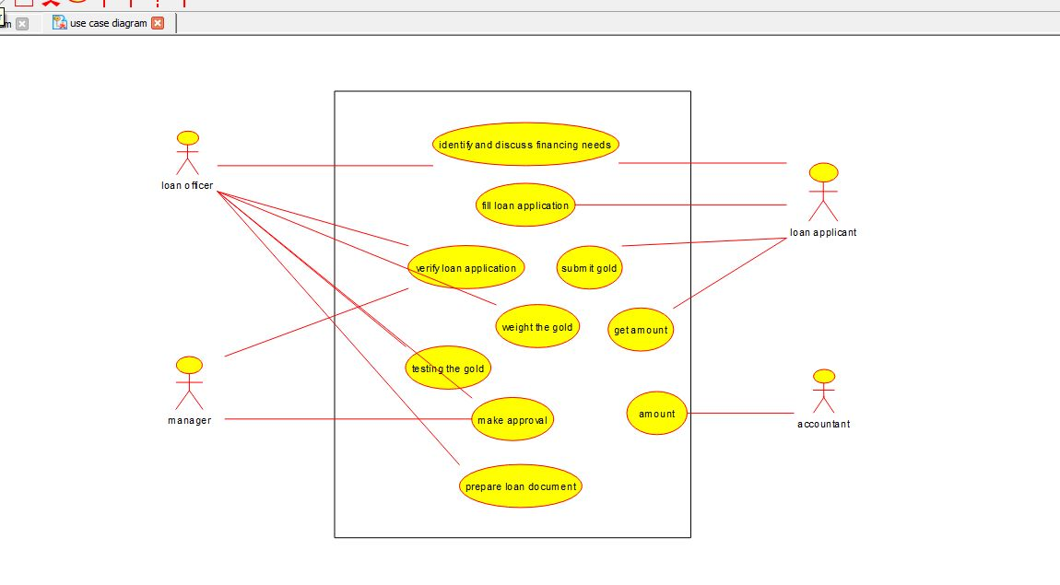

3.COLLABORATION:

